ABSTRACT

OpenGL provides a set of commands to render a three dimensional scene. That means you provide them in an Open GL-useable form and Open GL will show this data on the screen (render it). It is developed by many companies and it is free to use. You can develop Open GL-applications without licensing.
Open GL is a hardware- and system dependent interface. An Open GL-application will work on every platform, as long as there is an installed implementation, Because it is system independent, there are no functions to create windows etc., but there are helper functions for each platform. A very useful thing is GLUT.
The graphics project developed helps in demonstration of The Leaky Bucket Algorithm.The graph is a mathematical representation of the algorithm .The code was developed from scratch and can be used at both student at faculty level for understanding purposes.
The code for the calculation of points along the graph have been written in C.Along with a few graphics function we produce a nice colorful image with clarity which goes about implementing the package effectively without harming the originality of the package and also enhancing the visual appeal to the user.
The main objective of the package is to implement the algorithm for different inputs.We have also designed a pictorial representation the algorithm. These functions are implemented through various functions of OpenGL like primitives,Stings, Translation …etc each are explained in detail further .

ACKNOWLEDGEMENT

While presenting this Graphics Project on The Leaky Bucket I feel that it is our duty to acknowledge the help rendered to us by various persons.
I am grateful to my institution CMR Institute of Technology for providing me a congenial atmosphere to carry out the project successfully.
I would like to express my heartfelt gratitude to Dr. Sanjay R Chitnis, Principal, CMRIT, Bangalore, for extending his support.
I would also like to express my heartfelt gratitude to Mrs Swathi Y, Assoc Professor and Head of Department, Computer Science and Engineering whose guidance and support was truly invaluable.
I am very grateful to my guide, Mr. Mahesh D.S, Asst.Professor Department of Computer Science, for his able guidance and valuable advice at every stage of my project which helped me in the successful completion of my project.
I would also like to thank my computer Graphics teacher,Mr.Shivaraj V.B, for teaching me the basics and for helping me at every stage of the project development.I am indebted to my Parents and Friends for their continued moral and material support throughout the course of project.

CONTENTS
Abstract
Acknowledgement
1. Introduction 1.1 Introduction to Computer graphics
1.2 Areas of Application of Computer Graphics
1.3 Introduction to OpenGL
1.3.1 About OpenGL
1.3.2 Graphics Functions
2. Requirements Specification
2.1 Hardware Specification
2.2 Software Specification
3. Design
3.1 Flow Chart
4. Implementation
4.1 OpenGL functions details
4.2 Code in C-language
5. Testing
5.1 Goals of Testing
5.2 Testing of Spectrum
6. Discussions and Snapshots
6.1 A Brief Description of How Project Works
6.2 Screen Snapshots
7. Conclusion and Future Scope
9. References

LIST OF FIGURES

1. Fig 6.1: Input of packets via0’s and 1’s
2. Fig 6.2: Initial screen: A cover page giving us firsthand information about the algorithm.
3. Fig 6.3:Drop down menu options.
4. Fig 6.4:Plotting of the graph
5. Fig 6.5:Bucket showing pictorial representation of the same(algorithm).
6. Fig 6.6: EXIT

CHAPTER 1
INTRODUCTION
1.1 INTRODUCTION TO COMPUTER GRAPHICS
Computer Graphics is one of the most effective and commonly used methods to communicate the processed information to the user. It displays the information in the form of graphical objects such as pictures, charts, graphs and diagram instead of simple text.
Graphics often combine text, illustration, and color. Graphic design may consist of the deliberate selection, creation, or arrangement of typography alone, as in a brochure, flier, poster, web site, or book without any other element. Clarity or effective communication may be the objective, association with other cultural elements may be sought, or merely, the creation of a distinctive style.

Graphics can be functional or artistic. The latter can be a recorded version, such as a photograph, or an interpretation by a scientist to highlight essential features, or an artist, in which case the distinction with imaginary graphics may become blurred.
Computer Graphics today is largely interactive. The user controls the contents, structure, and appearance of objects and their displayed images by using input devices, such as a keyboard, mouse, or touch-sensitive panel on the screen.
Computer graphics concerns with the pictorial synthesis of real or imaginary objects from their computer based models, where as the related field of image processing treats the converse process, the analysis of scenes, or the reconstruction of models of 2D or 3D objects from their pictures.
A broad classification of major subfields in Computer Graphics might be:
- Geometry: Studies ways to represent and process surfaces.
- Animation: Studies ways to represent and manipulate motion.
- Rendering: Studies algorithms to reproduce light transport.
- Imaging: Studies image acquisition or image editing.
- Computer graphics: Computer graphics is concerned with all aspects of producing pictures and images using a computer.
- Translation: Translation is an operation that displaces points by a fixed size in a given direction.
- Rotation: Three features of transformation extended to other rotations
- There is one point in the origin that is unchanged by the rotation called fixed point.
- Two dimensional plane is a part of three dimensional space, we can reinterpret this rotation in three dimension.
- Rotation in the two dimensional plane z=0 is equivalent to a three dimensional rotation about the z-axis.
- Scaling: Scaling is a non rigid body transformation, by which, we can make an object bigger or smaller.

1.2 AREAS OF APPLICATION OF COMPUTER GRAPHICS
- User interfaces and Process control
- Cartography
- Office automation and Desktop publishing
- Plotting of graphs and charts
- Computer aided Drafting and designs
- Simulation and Animation

1.3 INTRODUCTION TO OpenGL
1.3.1 ABOUT OpenGL
OpenGL has become a widely accepted standard for developing graphics application. Most of our applications will be designed to access OpenGL directly through functions in three libraries. Functions in main GL library have names that begin with the letters gl and are stored in a library usually referred to as GL.
The second is the OpenGL Utility Library (GLU). This library uses only GL functions but contains code for creating common objects and simplifying viewing. All functions in GLU can be created from the core GL library. The GLU library is available in all OpenGL implementations; functions in the GLU library begin with the letters glu.
The third is called the OpenGL Utility Toolkit (GLUT), which provides the minimum functionality that should be expected in any modern windowing system.
GL
GLUT
GLX
Xlib, Xtk
Frame
buffer
OpenGL
Application
program

GLU
Fig 1.1: Library organization of OpenGL

1.3.2 GRAPHICS FUNCTIONS

Function calls Outputs
Application programs
Graphics system
Ip/op devices
Data Input
Fig 1.2: Graphics system as a black box.

Our basic model of a graphics package is a black box, a term that engineers use to denote a system whose properties are described only by its inputs and outputs. We describe an API through the functions in its library. Some of the functions are:
  - The primitive functions define the low-level objects or atomic entities that our system can display.
  - Attribute functions allow us to perform operations ranging from choosing the color with which we display a line segment, to picking a pattern with which to fill the inside of a polygon, to selecting a typeface for the titles of a graph.
  - Transformation function allows carrying out transformations of objects, such as rotation, translation, and scaling.
  - A set of input functions allow us to deal with the diverse forms of input that characterize modern graphics systems.
  - The control functions enable us to communicate with the window systems, to initialize our programs, and to deal with any errors that take place during the execution of programs.

CHAPTER 2
REQUIREMENTS SPECIFICATION

  - SOFTWARE SPECIFICATION
- Platform used: UBUNTU
- Technology used: OpenGL Libraries such has OpenGL Utility library, OpenGL Utility toolkit
- Language: C

2.2 HARDWARE SPECIFICATION
This package has been developed on:
- Pentium 4
- 40 GB hard disk
- 128 MB RAM
- VGA Color Monitor
- Input devices-key board, mouse

However it has been designed to work on systems with minimal resources.

CHAPTER 3
DESIGN
3.1 FLOWCHART
START
MAIN
INITIALIZE CALLBACK FUNCTIONS
MENU SCREEN IS DISPLAYED

INPUT ARRAY

ON CLICK MENU DISPLAYED
GRAPH

BUCKET
EXIT
GRAPH PLOTTED

BUCKET DISPLAYED
CONFORMING AND NON-CONFORMING PACKETS DISPLAYED

CONFORMING AND NON-CONFORMING PACKETS DISPLAYED

STOP
Fig 3.1:Flow chart
CHAPTER 4
IMPLEMENTATION
4.1 OpenGL FUNCTION DETAILS
- glutInitDisplayMode — sets the initial display mode.
    - Declaration: void glutInitDisplayMode (unsigned int mode);
    - Remarks: The initial display mode is used when creating top-level windows, sub windows, and overlays to determine the OpenGL display mode for the to-be-created window or overlay.
- glutInitWindowposition --- set the initial window position.
- Declaration: void glutInitWindowPosition(int x, int y);
x: Window X location in pixels.
y: Window Y location in pixels.
- glutInitWindowSize --- set the initial window size.
- Declaration: void glutInitWindowSize(int width,int height);
width: Width in pixels
height: Height in pixels.
- glutCreateWindow --- set the title to graphics window.
- Declaration: Int glutCreateWindow(char *title);
- Remarks: This function creates a window on the display. The string title can be used to label the window.The integer value returned can be used to set the current window when multiple windows are created.
- glutDisplayFunc
- Declaration: void glutDisplayFunc(void(*func)void));
- Remarks: This function registers the display function that is executed when the window needs to be redrawn.
- glClear:
- Declaration: void glClear();
- Remarks: This function clears the particular buffer.

- glClearColor:
- Declaration:
void glClearColor(GLfloat red, GLfloat green, Glfloat blue, Glfloat alpha);
- Remarks: This function sets the color value that is used when clearing the color buffer.

- glEnd
- Declaration: void glEnd();
- Remarks: This function is used in conjunction with glBegin to delimit the vertices of an opengl primitive.
- glMatrixMode
- Declaration: void glMatrixMode(GLenum mode);
- Remarks: This function specifies which matrix will be affected by subsequent transformations mode can be GL_MODELVIEW,GL_PROJECTION or GL_TEXTURE..
- glOrtho
- Declaration:
void glOrtho(GLdouble left, GLdouble right, GLdouble bottom,GLdouble top,GLdouble near,GLdouble far);
- Remarks: It defines an orthographic viewing volume with all parameters measured from the center of the projection plane.

- glIint

- Declaration:
Void glutInit(int *argc, char **argv).
Remarks: To start through graphics system, we must first call glutInit (),glutInit will initialize the GLUT library and negotiate a session with the window system. During this process, glutInit may cause the termination of the GLUT program with an error message to the user if GLUT cannot be properly initialized.

- glutAddMenuEntry
- Declaration:
Void glutAddMenuEntry(char *name,int value);
- Remarks: Adds a menu entry to the bottom of the current menu.The String name will be displayed for the newly added menu entry.An identifier is used to represent each option

- glutCreateMenu
- Declaration:
int glutCreateMenu(void ( *func)(int value));
- Remarks:It creates a new pop-up menu and returns a unique small integer identifier.The range of the allocated identifiers starts at 1.

4.2. CODE IN C LANGUAGE
/*LEAKY BUCKET ALGORITHM. PACKET SIZE=3,BUCKET LENGTH=9*/

#include<stdio.h>
#include<stdlib.h>
#include<string.h>
#include<GL/glut.h>

GLint PI[1][2]={10,10};//Initial (x,y) of the graph
GLint PF[1][2]={10,10};//Final (x,y) of the graph
GLint A[9]={0};//Original array for the packet input
GLint B[9]={0};//Final output to store the non-conforming/conforming packets
GLfloat a[2];//Droplets
GLfloat b[2];
GLfloat c[2];
GLfloat d[2];
GLfloat w[2];//Water inside the bucket
GLfloat x[2];
GLfloat y[2];
GLfloat z[2];
GLint cnt=0;//Count of non-coforming packets
int font;//font of text
int op;

void draw_line(GLint *a,GLint *b) //DRAW LINES
{
glColor3f(1.0,0.0,1.0);
glBegin(GL_LINES);
glVertex2iv(a);
glVertex2iv(b);
glEnd();
}

void draw_line_1() //DRAW LINES
{

glColor3f(1.0,0.0,1.0);
glBegin(GL_LINES);
glVertex2iv(PI[0]);
glVertex2iv(PF[0]);
glEnd();
}

void non_polygon(GLint *B ) //NON CONFORMING packets
{

int i,x,x1;
cnt=0;
for(i=0;i<9;i++)
{
if(B[i]==1)
{
cnt++;
x=(i*100)+10;
x1=((i+1)*100)+10;
glColor3f(1.0,0.0,0.0);
glBegin(GL_POLYGON);//To show the non-conforming packets on top
glVertex2i(x,930);
glVertex2i(x1,930);
glVertex2i(x1,980);
glVertex2i(x,980);
glEnd();
glColor3f(0.0,0.0,0.0);//Outline over each packet
glBegin(GL_LINE_LOOP);
glVertex2i(x,930);
glVertex2i(x1,930);
glVertex2i(x1,980);
glVertex2i(x,980);
glEnd();
}
}
}

void polygon(GLint *a) //CONFORMING PACKETS
{
int i,x,x1,v=10;
for(i=0;i<9;i++)
{
if(a[i]==1)
{
x=(i*100)+10;
x1=((i+1)*100)+10;
glColor3f(0.0,1.0,0.0);
glBegin(GL_POLYGON);//To show the conforming packets on top
glVertex2i(x,930);
glVertex2i(x1,930);
glVertex2i(x1,980);
glVertex2i(x,980);
glEnd();
glColor3f(0.0,0.0,0.0);
glBegin(GL_LINE_LOOP);//Outline over each packet
glVertex2i(x,930);
glVertex2i(x1,930);
glVertex2i(x1,980);
glVertex2i(x,980);
glEnd();
}

}
for(i=0;i<9;i++)
{
v=i*100+10;
glColor3f(1.0,1.0,1.0);//Marking on the packet line
glBegin(GL_LINES);
glVertex2i(v,930);
glVertex2i(v,940);
glEnd();
}
glColor3f(1.0,1.0,1.0);//Base of packet line on top
glBegin(GL_LINES);
glVertex2i(10,930);
glVertex2i(910,930);
glEnd();
}

void leaky_bucket() // ALGORITHM :CALCULATION
{

int i=0,j,k,count=0,val;
for(i=0;i<9;i++)//Finding the initial packet postion
{
if(A[i]==0)
count++;
else
break;
}
PI[0][0]+=(count*100);
j=i;//First packet
PF[0][0]+=count*100;
while(j<9)
{
count=0;
if(A[j]==1)
{
PF[0][1]+=300;
if(PF[0][1]>910)
{
PF[0][1]-=300;
B[j]=1;

}
draw_line(PI[0],PF[0]);//Vertical Line,I=3
PI[0][0]=PF[0][0];
PI[0][1]=PF[0][1];
PF[0][0]+=100;//Drop after every addition of packet
PF[0][1]-=100;
draw_line(PI[0],PF[0]);//Draw the drop
PI[0][0]=PF[0][0];
PI[0][1]=PF[0][1];
j++;
}
else
{
for(k=j;k<9;k++)//Finding the next packet
{
if(A[k]==0)
count++;
else
break;
}
PF[0][1]=PF[0][1]-(100*count);
PF[0][0]=PF[0][0]+(100*count);
if(PF[0][1]<10)
{
val=10-PF[0][1];
PF[0][0]-=val;
PF[0][1]=10;
draw_line(PI[0],PF[0]);
PI[0][0]=PF[0][0]+val;
PI[0][1]=PF[0][1];
PF[0][0]+=val;

}
else
{
draw_line(PI[0],PF[0]);
PI[0][0]=PF[0][0];
PI[0][1]=PF[0][1];
}
j=k;
}

}
non_polygon(B);
}

void display2()//Bucket
{
int i,j,k,Y1,Y2;
a[0]=395.0; a[1]=767.0;
b[0]=405.0; b[1]=767.0;
c[0]=405.0; c[1]=792.0;
d[0]=395.0; d[1]=792.0;
w[0]=300.0; w[1]=350.0;
x[0]=500.0; x[1]=350.0;
y[0]=535.0; y[1]=475.0;
z[0]=265.0; z[1]=475.0;
glClear(GL_COLOR_BUFFER_BIT);
glPointSize(5.0);

//bucket
glColor3f(1.0,0.0,0.0);
glBegin(GL_LINE_LOOP);
glVertex2f(300.0,350.0);
glVertex2f(500.0,350.0);
glVertex2f(550.0,525.0);
glVertex2f(250.0,525.0);
glEnd();

//water
glColor3f(0.0,0.0,1.0);
glBegin(GL_POLYGON);
glVertex2fv(w);
glVertex2fv(x);
glVertex2fv(y);
glVertex2fv(z);
glEnd();

glColor3f(1.0,1.0,0.0);
char s[]="INCOMING PACKETS";
glRasterPos2f(300.0,800.0);
for(i=0;s[i]!='\0';i++)
glutBitmapCharacter(GLUT_BITMAP_HELVETICA_18,s[i]);

glColor3f(2.0,1.0,1.0);
char O[]="PICTORIAL REPRESENTATION";
glRasterPos2f(300.0,900.0);
for(i=0;O[i]!='\0';i++)
glutBitmapCharacter(GLUT_BITMAP_HELVETICA_18,O[i]);

for(i=0;i<9;i++)//Droplet
{
if (A[i]==1)//Packet
{
glColor3f(0.0,0.0,1.0);
glBegin(GL_POLYGON);
glVertex2fv(a);
glVertex2fv(b);
glVertex2fv(c);
glVertex2fv(d);
glEnd();
}
else//Not existing packet
{ glColor3f(0.0,0.0,1.0);
glBegin(GL_LINE_LOOP);
glVertex2fv(a);
glVertex2fv(b);
glVertex2fv(c);
glVertex2fv(d);
glEnd();
}
a[1]-=30;
b[1]-=30;
c[1]-=30;
d[1]-=30;

}
glColor3f(1.0,0.0,1.0);
char f[]="NON CONFORMING PACKETS";
glRasterPos2f(570.0,525.0);
for(i=0;f[i]!='\0';i++)
glutBitmapCharacter(GLUT_BITMAP_HELVETICA_18,f[i]);

for(j=0;j<cnt;j++)//525=Rim of bucket
{ Y1=525-j*30;
Y2=510-j*30;

glColor3f(1.0,0.0,0.0);
glBegin(GL_LINE_LOOP);//Drawing the non-conforming packets along the rim
glVertex2i(550,Y1);
glVertex2i(560,Y1);
glVertex2i(560,Y2);
glVertex2i(550,Y2);
glEnd();
}

glColor3f(0.0,1.0,1.0);
char r[]="CONFORMING PACKETS";
glRasterPos2f(415.0,290.0);
for(i=0;r[i]!='\0';i++)
glutBitmapCharacter(GLUT_BITMAP_HELVETICA_18,r[i]);

k=0;
for(j=0;j<9;j++)//525=Rim of bucket
{
if(B[j]==0 && A[j]==1)
{
Y1=350-k*30;
Y2=335-k*30;

glColor3f(0.0,1.0,0.0);
glBegin(GL_LINE_LOOP);//Drawing the non-conforming packets along the rim
glVertex2i(395,Y1);
glVertex2i(405,Y1);
glVertex2i(405,Y2);
glVertex2i(395,Y2);
glEnd();
k++;
}

}
}

void display1()//Drawing the Graph
{

PI[0][1]=10;PI[0][0]=10;
PF[0][1]=10;PF[0][0]=10;

glClear(GL_COLOR_BUFFER_BIT);
glPointSize(5.0);
glColor3f(1.0,1.0,1.0);
glBegin(GL_LINES);
glVertex2i(10,10);
glVertex2i(910,10);
glEnd();
glBegin(GL_LINES);
glVertex2i(10,10);
glVertex2i(10,910);
glEnd();
int i,a=10,b=10;
for(i=0;i<9;i++)
{
a=a+100;
glColor3f(1.0,1.0,1.0);
glBegin(GL_LINES);
glVertex2i(a,10);
glVertex2i(a,20);
glEnd();
}
a=10;
for(i=0;i<9;i++)
{
a=a+100;
glColor3f(1.0,1.0,1.0);
glBegin(GL_LINES);
glVertex2i(10,a);
glVertex2i(20,a);
glEnd();
}
polygon(A);
leaky_bucket();

glColor3f(1.0,1.0,0.0);
char T[]="KEY";
glRasterPos2f(600.0,300.0);
for(i=0;T[i]!='\0';i++)
glutBitmapCharacter(GLUT_BITMAP_HELVETICA_18,T[i]);

glColor3f(0.0,1.0,0.0);
char U[]="GREEN";
glRasterPos2f(600.0,250.0);
for(i=0;U[i]!='\0';i++)
glutBitmapCharacter(GLUT_BITMAP_HELVETICA_18,U[i]);

glColor3f(0.0,1.0,1.0);
char V[]=": CONFIRMING PACKETS";
glRasterPos2f(700.0,250.0);
for(i=0;V[i]!='\0';i++)
glutBitmapCharacter(GLUT_BITMAP_HELVETICA_18,V[i]);

glColor3f(1.0,0.0,0.0);
char W[]="RED";
glRasterPos2f(600.0,200.0);
for(i=0;W[i]!='\0';i++)
glutBitmapCharacter(GLUT_BITMAP_HELVETICA_18,W[i]);

glColor3f(0.0,1.0,1.0);
char X[]=": NON CONFORMING PACKETS";
glRasterPos2f(700.0,200.0);
for(i=0;X[i]!='\0';i++)
glutBitmapCharacter(GLUT_BITMAP_HELVETICA_18,X[i]);

glFlush();
if(op==2)
display2();//Page displaying Bucket
}

void display()//Main Page
{
int i;
glClear(GL_COLOR_BUFFER_BIT);
glColor3f(1.0,0.0,0.0);
char f[]="LEAKY BUCKET ALGORITHM";
glRasterPos2f(400.0,900.0);
for(i=0;f[i]!='\0';i++)
glutBitmapCharacter(GLUT_BITMAP_HELVETICA_18,f[i]);

glColor3f(0.0,0.0,1.0);
char g[]="WHERE";
glRasterPos2f(300.0,800.0);
for(i=0;g[i]!='\0';i++)
glutBitmapCharacter(GLUT_BITMAP_HELVETICA_18,g[i]);

glColor3f(0.0,1.0,0.0);
char h[]="PACKET SIZE (I) : 3";
glRasterPos2f(400.0,750.0);
for(i=0;h[i]!='\0';i++)
glutBitmapCharacter(GLUT_BITMAP_HELVETICA_18,h[i]);

glColor3f(0.0,1.0,0.0);
char e[]="BUCKET DEPTH (L) : 9";
glRasterPos2f(400.0,700.0);
for(i=0;e[i]!='\0';i++)
glutBitmapCharacter(GLUT_BITMAP_HELVETICA_18,e[i]);

glColor3f(1.0,1.0,0.0);
char t[]="DONE BY:";
glRasterPos2f(200.0,400.0);
for(i=0;t[i]!='\0';i++)
glutBitmapCharacter(GLUT_BITMAP_HELVETICA_18,t[i]);

glColor3f(1.0,0.0,1.0);
char s[]="1CR12CS094";
glRasterPos2f(200.0,350.0);
for(i=0;s[i]!='\0';i++)
glutBitmapCharacter(GLUT_BITMAP_HELVETICA_18,s[i]);

glColor3f(0.0,1.0,1.0);
char u[]="SHREYA K.S.";
glRasterPos2f(350.0,350.0);
for(i=0;u[i]!='\0';i++)
glutBitmapCharacter(GLUT_BITMAP_HELVETICA_18,u[i]);

glColor3f(1.0,0.0,1.0);
char v[]="1CR12CS095";
glRasterPos2f(200.0,300.0);
for(i=0;v[i]!='\0';i++)
glutBitmapCharacter(GLUT_BITMAP_HELVETICA_18,v[i]);

glColor3f(0.0,1.0,1.0);
char w[]="SHREYA VISHWANATH RAO";
glRasterPos2f(350.0,300.0);
for(i=0;w[i]!='\0';i++)
glutBitmapCharacter(GLUT_BITMAP_HELVETICA_18,w[i]);
}

void demo_menu(int id)
{ op=id;
switch(id)
{
case 1: display1();
break;
case 2:display1();
break;
case 3:exit(0);
break;
}
glutPostRedisplay();
}

void myinit()
{
glMatrixMode(GL_PROJECTION);
glLoadIdentity();
gluOrtho2D(0.0,1000.0,0.0,1000.0);
glMatrixMode(GL_MODELVIEW);
glutPostRedisplay();
}

int main(int argc,char **argv)
{

printf("Given nine slots, select your packets in binary values\n");
printf("Choose \n 1 : Including a packet\t 0 : Excluding a packet\n");
int i;
for(i=0;i<9;i++)
{
scanf("%d",&A[i]);
}
glutInit(&argc,argv);
glutInitDisplayMode(GLUT_SINGLE|GLUT_RGB);
glutInitWindowSize(1000,1000);
glutInitWindowPosition(0,0);
glutCreateWindow("Leaky Bucket");
glutCreateMenu(demo_menu);
glutAddMenuEntry("Graph",1);
glutAddMenuEntry("Bucket",2);
glutAddMenuEntry("Exit",3);
glutAttachMenu(GLUT_RIGHT_BUTTON);
glutDisplayFunc(display);
glClearColor(0.0,0.0,0.0,0.0);
myinit();
glutMainLoop();
return 0;
}

CHAPTER 5
TESTING
The general testing process that started with the testing of individual program units such as functions or objects. The model of testing process is appropriate for large systems, or for systems that are developed through reuse.The fundamental testing activities are
- Component testing: Testing the parts of system.
- System testing: Testing the system as whole.

5.1 GOALS OF TESTING
The general aim of testing is to affirm the quality of software systems by systematically exercising the software in carefully controlled circumstances.
5.2 TESTING SPECTRUM:
Testing is involved in every stage of software life cycle, but the testing done at each level of software development is different in nature and has different objectives.
- Unit Testing is done at the lowest level. It tests the basic unit of software, which is the smallest testable piece of software, and is often called “unit”, “module”, or “component” interchangeably.

- Integration Testing is performed when two or more tested units are combined into a larger structure.The test is often done on both the interfaces between the components and the larger structure being constructed, if its quality property cannot be assessed from its components.

- Validation Testing The goal of validation testing is to expose latent defects in a software system before the system is delivered. This contrasts with validation testing which is intended to demonstrate that a system meets its specification. Validation testing requires the system to perform correctly using given acceptance test cases.
- System Testing tends to affirm the end-to-end quality of the entire system. System test is often based on the functional/requirement specification of the system. Non-functional quality attributes, such as reliability, security, and maintainability, are also checked.

- Unit testing
Test of source code.
Expected output: Demonstration of the Leaky Bucket Algorithm.
Actual output: Demonstration of the Leaky Bucket Algorithm.

- Integration testing
Compilation of source code
Expected output: Executed Command prompt
Actual output: Executed Command prompt

- System testing
Creation of application
Expected output: leaky.c with 0 errors and 0 warnings.
Actual output: leaky.c with 0 errors and 0 warnings.

- Validation testing
Expected output :Displays conforming and non-conforming packets.
Actual output : Displays conforming and non-conforming packets.

CHAPTER 6
DISCUSSIONS AND SNAPSHOTS

6.1 A BRIEF DESCRIPTION ON HOW THE PROJECT WORKS
The Leaky Bucket is an algorithm used in packet switched networks and telecommunications networks.The project helps in easy understanding of how packets are dealt with in a network.Input is the incoming packets in the form of a binary array.Given unit time interval, we have values to represent packets,1:incoming 0:no packet .A graph is then plotted showing conforming and non-conforming packets.We also have an animated bucket to show packets that travel through the network without hassles.Text strings help differentiate between conforming and non-conforming packets.Menus help navigate through the project giving the user privilege of choice.An exit option terminates the algorithm demo.I,the packet size,is 3 and L,the bucket depth,is 9.Right click to initiate the project once the binary array is fed.
6.2 SCREEN SNAPSHOTS
Fig 6.1: Input of packets via0’s and 1’s
Fig 6.2: Initial screen: A cover page giving us firsthand information about the algorithm.
Fig 6.3:Drop down menu options.
Fig 6.4:Plotting of the graph
Fig 6.5:Bucket showing pictorial representation of the same(algorithm).
Fig 6.6: EXIT

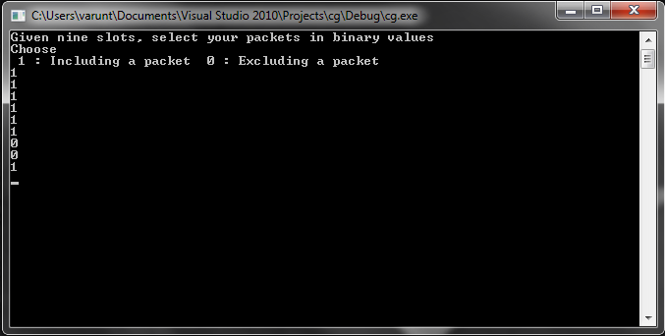
Fig 6.1: Input of packets via0’s and 1’s

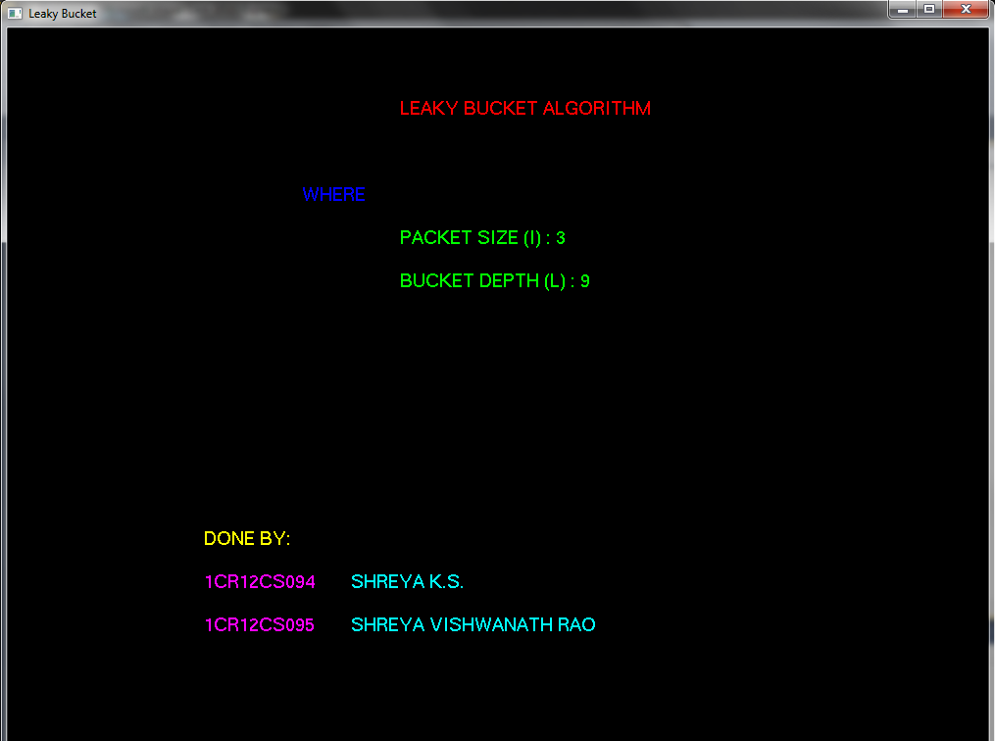

Fig 6.2: Initial screen: A cover page giving us firsthand information about the algorithm.
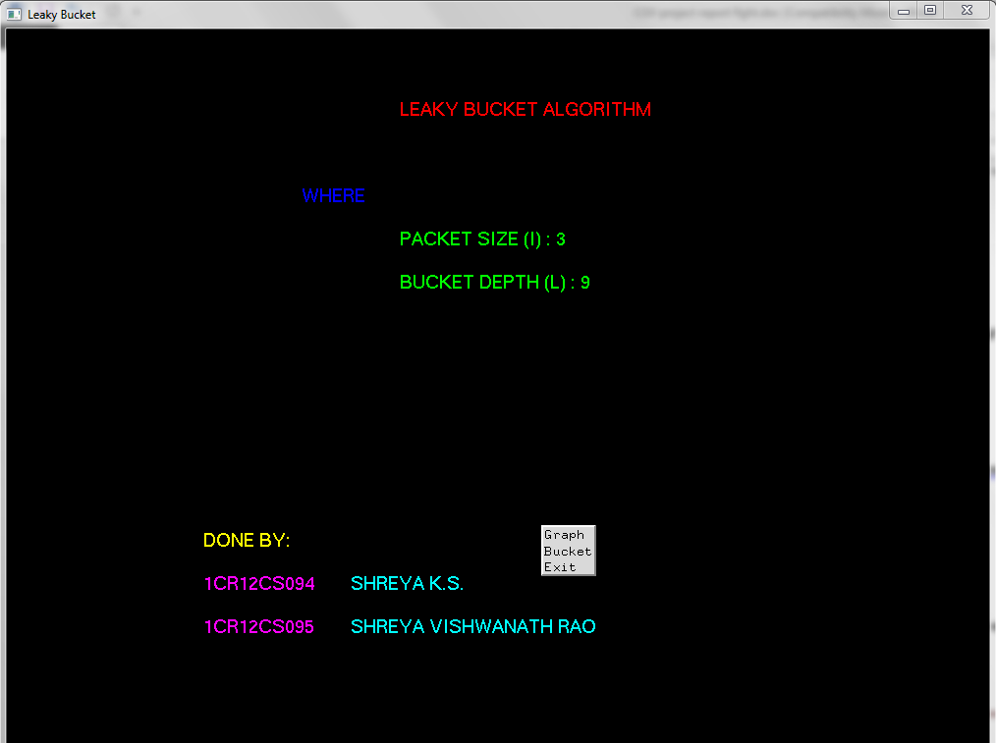
Fig 6.3:Drop down menu options.
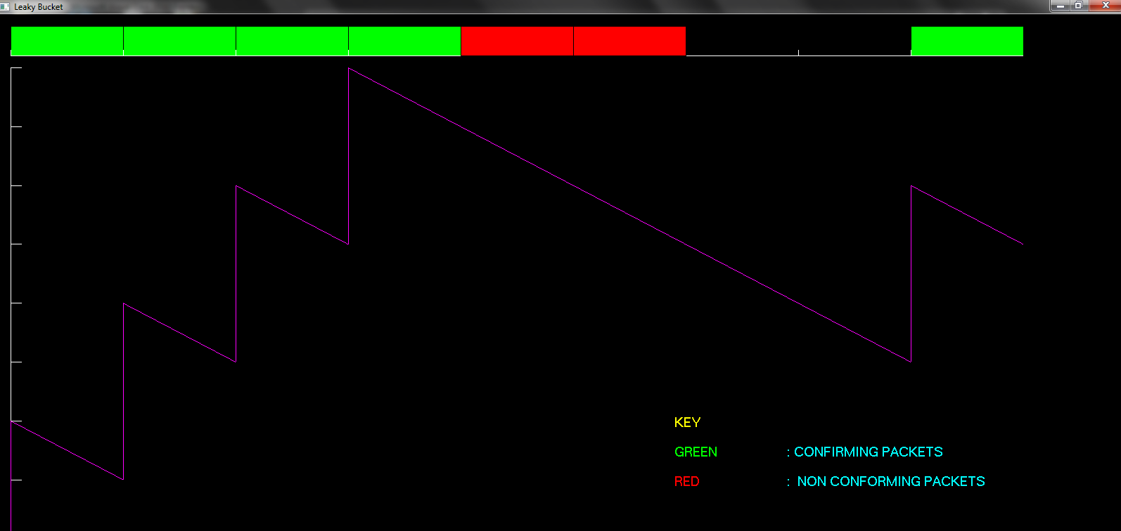
Fig 6.4:Plotting of the graph
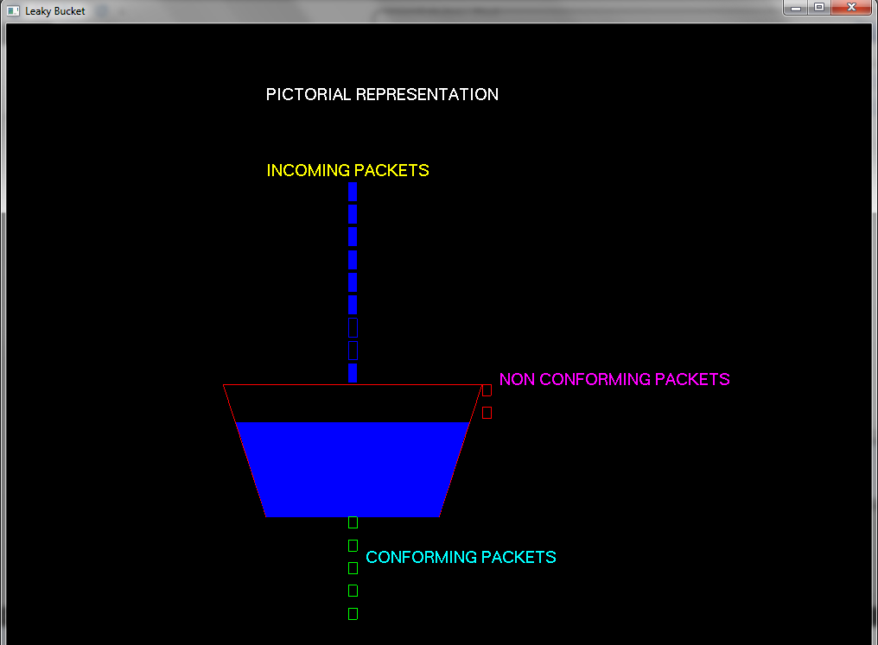
Fig 6.5:Bucket showing pictorial representation of the same(algorithm).
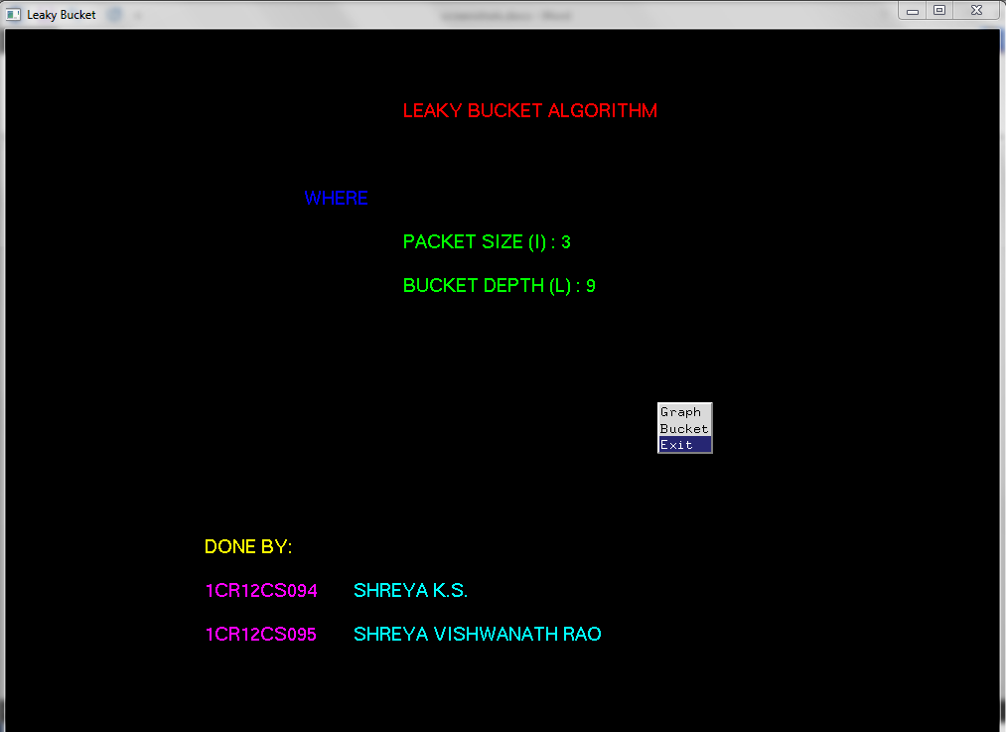
Fig 6.6: Exit
CHAPTER 7
CONCLUSION AND FUTURE SCOPE
During the course of designing this project I have understood various concepts of OpenGL clearly.It was a challenging task as the topic is a mixture of OpenGL programming and computer networks . I have tried to my best potential to incorporate all the basic level requirements of a normal graphics package .

Owing to certain constraints I could not incorporate all the tasks that a graphics package should perform. However it meets the basic requirements of the user successfully. Since it’s user friendly it enables the user to interact effectively and easily.

Special attention has been provided to generation of the graph, menus and deciding conforming and non-conforming packets.

This project has been designed using OpenGL libraries which works on the Ubuntu platform. The same can be done using other languages like Visual Studio and better graphical interfaces.Other improvements can be

- Higher languages like JAVA can be used to provide a new look to the project.
- We can also show the concept using bigger screen with smaller units to represent more number of packets.

REFERENCES

- Edward Angel, “Interactive Computer Graphics”,5th edition, Pearson Education,2005

- “Computer Graphics”, Addison-Wesley 1997 James D Foley, Andries Van Dam, Steven

- http://basic4gl.wikispaces.com

- http://www.wikipedia.com

- Communication Networks –Fundamental Concepts and Key Architectures - Alberto Leon-Garcia and Indra Widjaja, 2nd Edition,

